

Practices for Secure Software Report

Table of Contents
Document Revision History 3
Client 3
Instructions 3
Developer 4
1. Algorithm Cipher 4
2. Certificate Generation 4
3. Deploy Cipher 4
4. Secure Communications 4
5. Secondary Testing 4
6. Functional Testing 4
7. Summary 4
8. Industry Standard Best Practices 4

Document Revision History

Version | Date | Author | Comments
1.0 | 10/25/2026 | Nick Scott | First Draft

Client



Instructions

Submit this completed practices for secure software report. Replace the bracketed text with the relevant information. You must document your process for writing secure communications and refactoring code that complies with software security testing protocols.

- Respond to the steps outlined below and include your findings.
- Respond using your own words. You may also choose to include images or supporting materials. If you include them, make certain to insert them in all the relevant locations in the document.
- Refer to the Project Two Guidelines and Rubric for more detailed instructions about each section of the template.

Developer
Nick Scott

Algorithm Cipher

The SHA-256 algorithm cipher is recommended for Artemis Financial to use for their software. It will be important to encrypt the data in communications with their clients as they contain highly sensitive information regarding the finances and personal information of both the client and Artemis Financial. SHA-256 is a deterministic hash function where an input will always output the exact 256-bit sequence. It is extremely resilient to collisions, which is what happens when two inputs result in the same hash code.

Some encryption methods require the use of keys to both encrypt and decrypt a message. Keys are generated randomly, but the issue with this is computers can only create “pseudorandom numbers”. This means an algorithm is given a seed and then outputs a deterministic “random” number based on this seed and the algorithm. When the same key is used to both encrypt and decrypt data, it is known as “symmetric”. If a different key is used for each direction, then it is “asymmetric”. Because keys are incredibly important, the seed for the random number generator would need to be changed often so that the pattern cannot be identified by a hacker. Additionally, these keys need to be kept incredibly safe, as exposure to the key would mean free encryption and decryption for attackers.

SHA-256 is neither asymmetric or symmetric. This is because this hash function is one-way; it always turns the same input into the same hash sequence, and it is near impossible to decrypt the original data given just the hash code.

In 2017, researchers were able to engineer a collision attack on SHA’s older sibling, SHA-1. This means they could get the same hash code from two completely different inputs. SHA-1, at 160 bits, was proved to be unsafe, which is why standards have been raised to use a slower (but safer) algorithm: SHA-256. If Artemis Financial wishes, an even newer standard, called SHA-3, can go up to 512 bits, which would be even more difficult to engineer a collision than the already-safe SHA-256, at the cost of slow performance. Because Artemis Financial needs to communicate frequently and often, SHA-256 was chosen as the perfect middle ground.

Certificate Generation
Insert a screenshot below of the CER file.

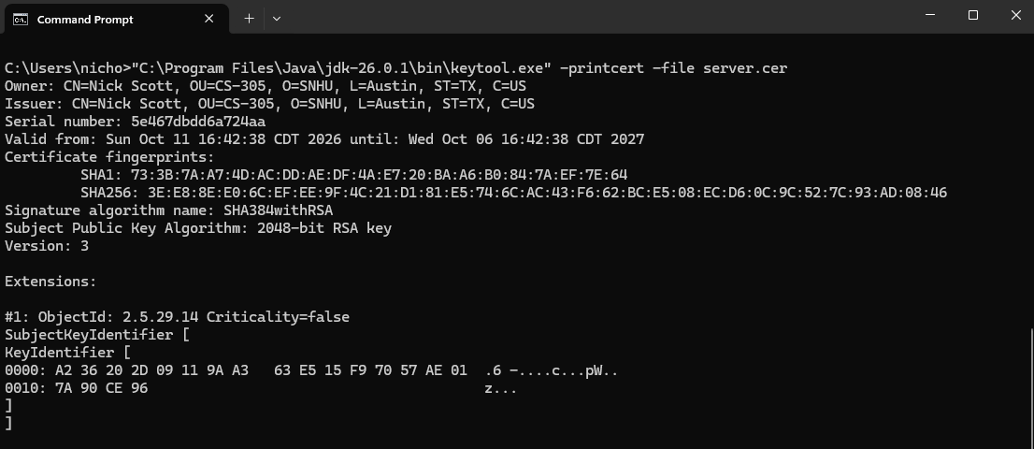
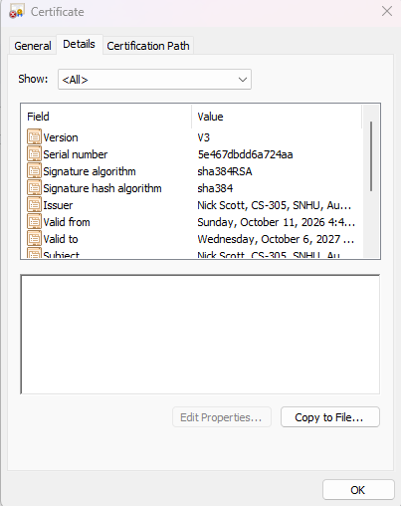

Deploy Cipher
Insert a screenshot below of the checksum verification.

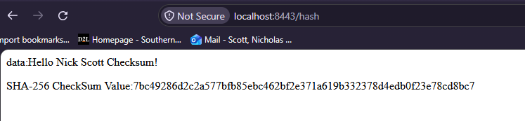

Secure Communications
Insert a screenshot below of the web browser that shows a secure webpage.

Note: Screenshot above says “Not Secure”, but certificate was applied correctly, as shown below.

The web browser will continue to say “Not Secure” until a certificate is provided by a CA.
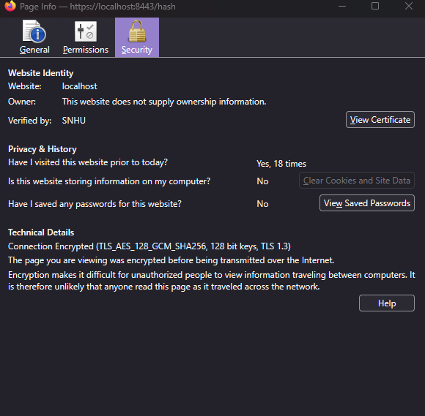
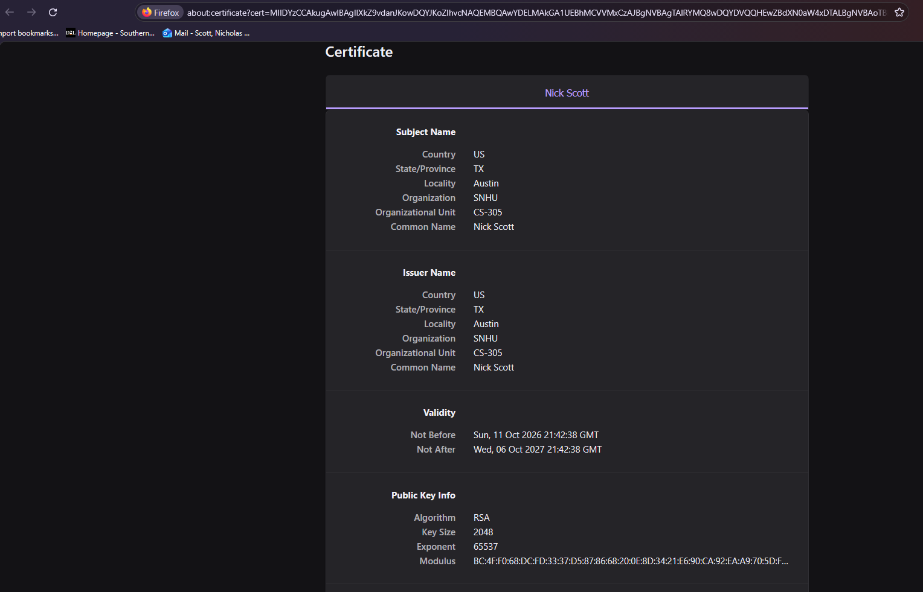
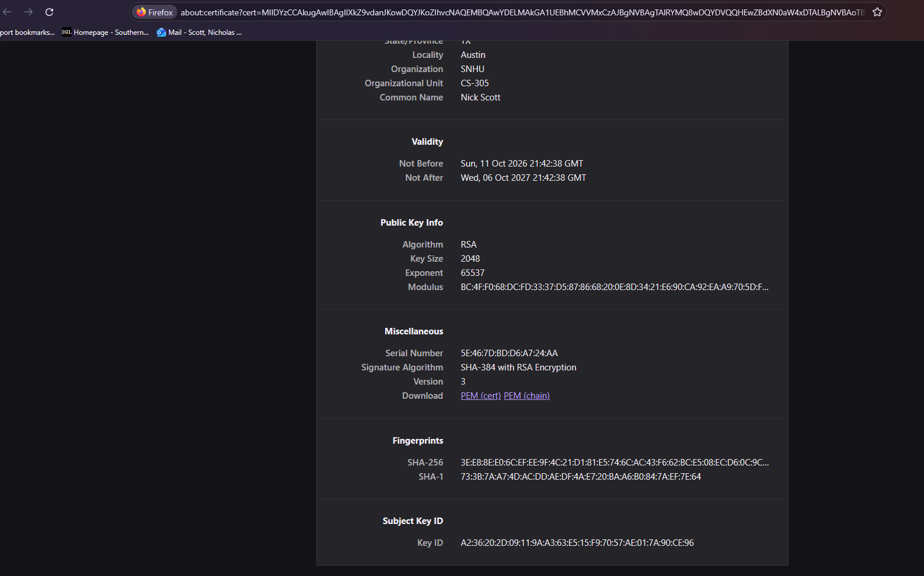

Secondary Testing
Insert screenshots below of the refactored code executed without errors and the dependency-check report.

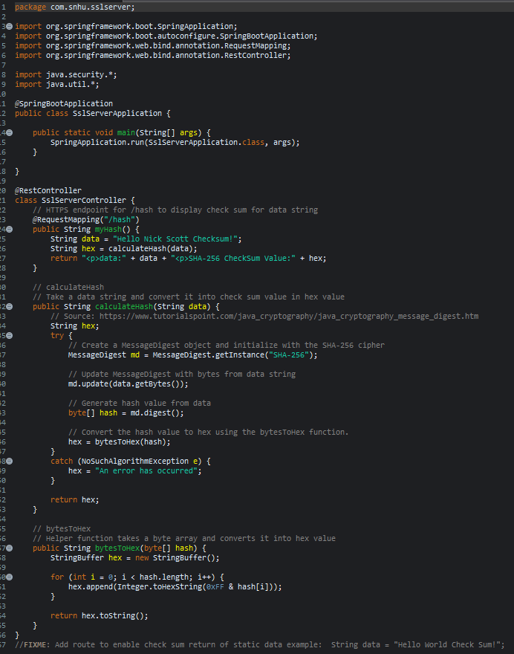
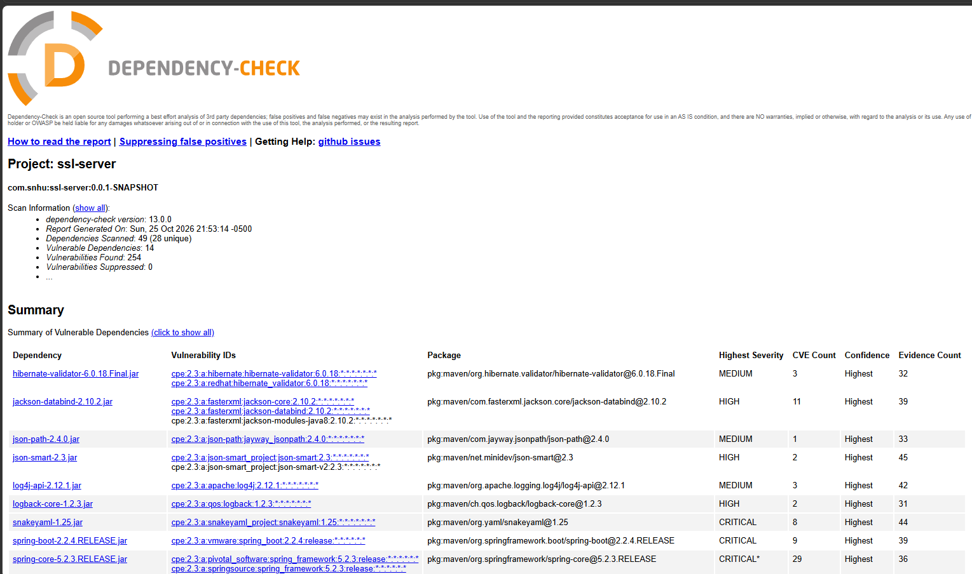

Functional Testing
Insert a screenshot below of the refactored code executed without errors.

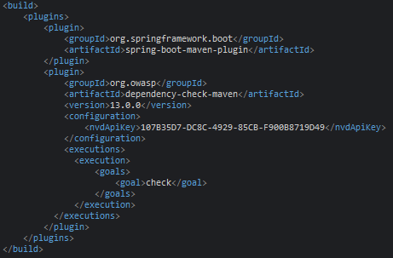
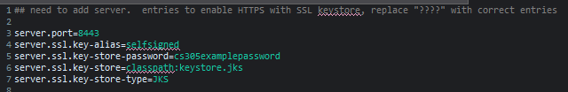

Summary
Areas of Security Addressed:
- Secure API Interactions:
The RestController was added in order to provide a secure endpoint for “/hash”. The html is exposed only when the user navigates to the correct endpoint from the server. The Spring Framework is used to ensure that the API interaction is secure. The self signed certificate is used with HTTPS to ensure that the website is “trusted”. Further security would be improved through the generation of a certificate with a Certificate Authority (CA).
- Cryptography:
The SHA-256 hash was successfully implemented to encrypt the data string. The generated hash-code is unique to my data string “Hello Nick Scott!”. An attacker would be unable to undo the SHA-256 hash, as it is a one-way cipher.
- Code Error:
I implemented error handling with a try-catch block in my refactored code. This way, if an error were to occur, such as a NoSuchAlgorithmException, the error would be displayed to the user, rather than crashing the entire website.
- Code Quality:
The application has been broken up through multiple functions. If errors or bugs were to arise, it would be easier to address by looking for the corresponding helper function and its functionality. Style has been followed, and commented thoroughly to assist any developer who will look at the codebase in the future.

Industry Standard Best Practices

The vulnerability report was updated to the most recent version (13.0.0) and provided with a unique NVD API Key that belongs only to me, Nick Scott. This way, the developers are aware of the most up-to-date vulnerabilities with the current version of Maven and Spring Boot used. It is important for developers to continually keep themselves up to date with the vulnerabilities and risks produced by the libraries used in the application.

Code reviews are important to do so that any possible problems with the code are properly addressed. For example, during my code review, I noticed that the application needed to properly handle “code error handling” so that the application can continue to run smoothly. Additionally, I made sure to make the code organized and easy-to-read so that future problems can be addressed quickly by developers.
Making sure to do industry standard best practices is essential so that security problems are addressed. Most often, a developer is not working alone, so being purposeful and thoughtful with how code is written is important so that vulnerabilities aren’t introduced by multiple parties. Especially when working with a company like Artemis Financial, clients’ personal information and sensitive financial information is worked with, so it is essential to make sure their data is secure. Clients need to have trust that their info is safe, otherwise, Artemis Financial would lose their customer base.

